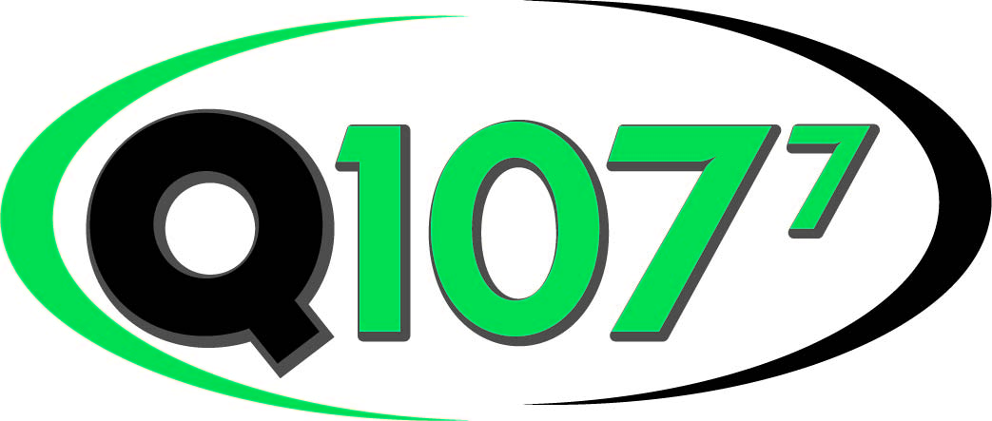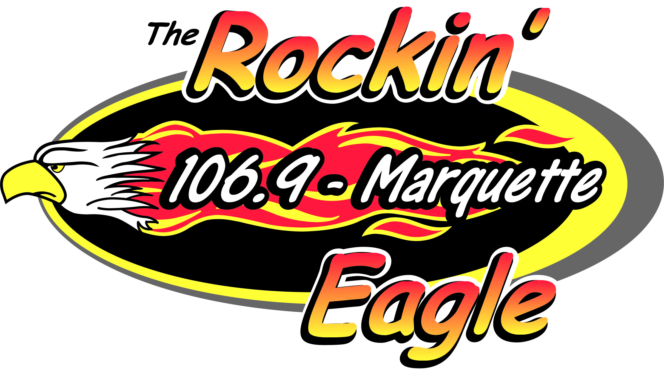

Eagle Radio EEO Public File Report

June 1, 2024

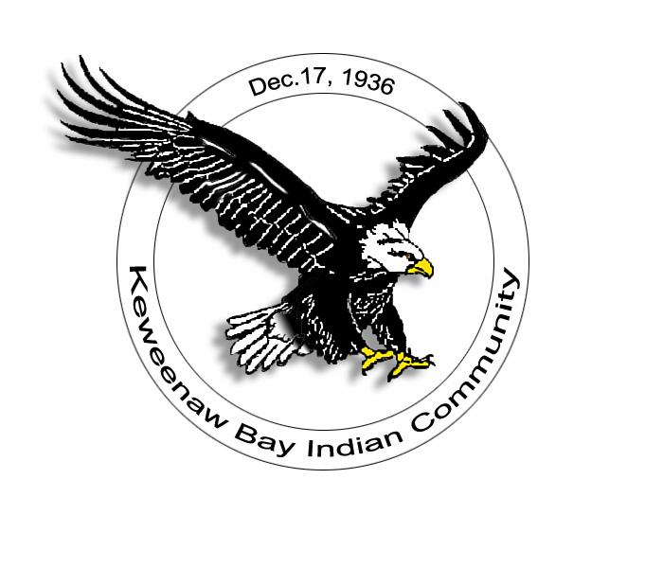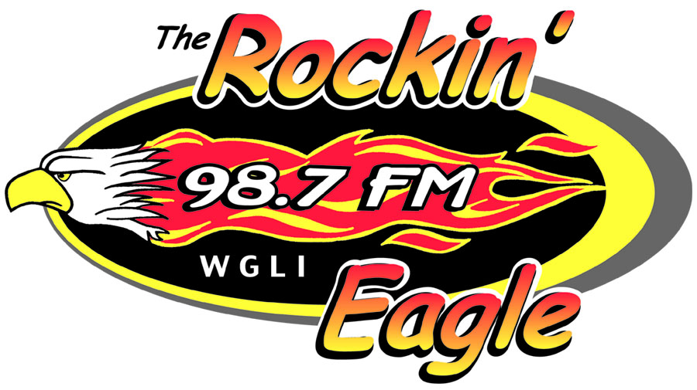

**EEO PUBLIC FILE REPORT**

For the 12-month Period: **June 1st, 2023 to May 31, 2024**

Prepared By: **Keweenaw Bay Indian Community**

(License/Permittee)

This report covers the following employment unit:

|  |  |  |  |  |
| --- | --- | --- | --- | --- |
| Call Sign  WCUP  WGLI  WMQT  WZAM | Facility ID Number  36092  38128  64503  64504 | Type of Station  FM Station  FM Station  FM Station  FM Station | Location  City, State  L’Anse, MI  Hancock, MI  Marquette, MI  Ishpeming, MI | LMA |

Total Full-Time Employees: 7

1. The following is a list of all vacancies for full-time jobs filled during the previous 12 months:

Job Title Date of Opening Date Filled

Account Executive/Sales 6/24/2022 7/31/2023

B. During the previous 12 months, the following recruitment sources were contacted as vacancies for full-time jobs opened. Those with an asterisk (*) were organizations that requested to be contacted as job openings occurred:

Recruitment Source Address Person Contact Number

1. Keweenaw Bay 16429 Beartown Road Hope Laramore 906-353-6623

Indian Community Baraga, MI 49908 Personnel Director

2. Tribal Employment 16429 Beartown Road Debbie Piccano 906-353-6623

Rights Office Baraga, MI 49908 TERO/Workforce Director

3. Michigan Works Houghton, MI 49931 [www.michiganworks.com](http://www.michiganworks.com) Online

4. Michigan Works Marquette, MI 49855 [www.michiganworks.com](http://www.michiganworks.com) Online

5. Eagle Radio 805B US 41 S. Ed Janisse/ 906-353-9287

Baraga, MI 49908 General Manager

6. Indeed Marquette, MI [www.indeed.com](http://www.indeed.com) Online

Baraga, MI

7. TV6 Advertisement 177 U.S. East Chad Cole 989-254-4858 Negaunee, MI 49866 Account Executive

8. NMU Careers 1401 Presque Isle Kara Cox 906-228-2500

Marquette, MI 49855 Representative

9. KBIC Web Site 16429 Beartown Road David Zasadnyi 906-353-6623

Baraga, MI 49908 IT Manager

10. Michigan Association 819 N. Washington Ave [mab@michmab.com](mailto:mab@michmab.com) 517-484-7444

Of Broadcasters Lansing, MI 48906

C. The following is a list of the sources for full-time jobs shown in Section B above and the recruitment source which provided the hire for that position:

|  |  |  |  |  |  |  |  |  |  |  |  |  |  |  |  |  |  |  |  |  |  |  |  |  |  |
| --- | --- | --- | --- | --- | --- | --- | --- | --- | --- | --- | --- | --- | --- | --- | --- | --- | --- | --- | --- | --- | --- | --- | --- | --- | --- |
| |  |  |  |  | | --- | --- | --- | --- | | Job Title | Recruitment Sources Used | Source of Hire | Date Hired | |  |  |  |  | | Account Executive/Sales | 1,2,3,4,5,6,7,8,9,10 | 5 | 7/31/2023 | |  |  |  |  | |  |  |  |  | |  |  |  |  | |  |

D. During the previous 12 months, there were a total of 1 person interviewed for vacancies for full-time positions. The following is a list of the total number of interviewees referred by each recruitment source shown in above:

Recruitment Source Total No. of Interviewees

Eagle Radio 1

E. During the last 12 months, the station employment unit engaged in the following initiatives (provide full details, including an explanation if not such initiatives were conducted during the period involved):

| Activity Category | Participation Details |
| --- | --- |
| Participation in at least four job fairs by station personnel who have substantial responsibility in the making of hiring decisions | Northern Michigan University hosted a job fair for employers which we participated in on October 25th, 2023 from 1pm to 4pm. Todd Forslund (HR Director) attended the event on behalf of Eagle Radio and interacted with students about job opportunities with Eagle Radio. |
|  | Northern Michigan University hosted a job fair for employers which we participated in on February 21st, 2024 from 1pm to 4pm. Todd Forslund (HR Director) and Tom Mogush (Eagle Radio Manager) attended the event and interacted with students about job opportunities with Eagle Radio. |
|  | Keweenaw Bay Ojibwa Community College held a job fair for employers which we participated in on March 26th, 2024 from 10am to 2pm. Dorothy Pryor (HR Specialist) attended the event on behalf of Eagle Radio and interacted with students about job opportunities with Eagle Radio. |
| Participation in at least four events or programs sponsored by educational institutions relating to career opportunities in broadcasting | During the 2023-2024 school year we utilized students from Westwood High School to operate the video camera during the Facebook live video coverage of Boys and Girls basketball games on WZAM. Each student was given a brief demonstration of how to work the camera and how to follow the action on the court. In all, 31 games were covered. There were a few students who did it multiple times and one mentioned that he might want to go into media production in college. |
| Participation in job banks, Internet programs, and other programs designed to promote outreach generally (*i.e.,* that are not primarily directed to providing notification of specific job vacancies) | Eagle Radio’s membership in the Michigan Association of Broadcasters supports their job bank and information disseminated about careers in broadcasting. |